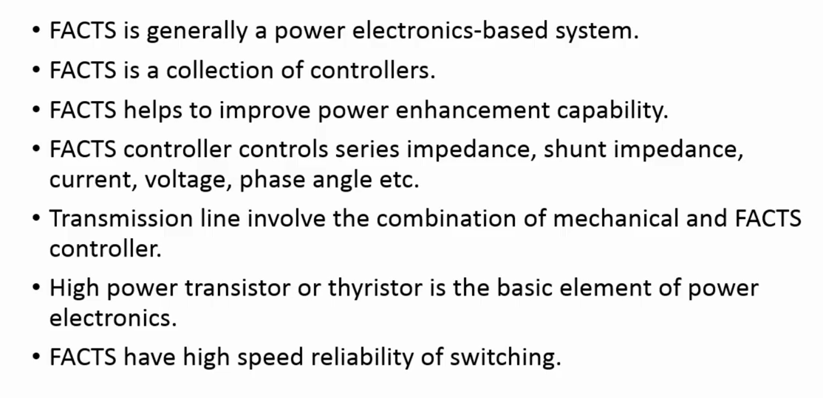



***For the few decades this power system is facing a problem of the peak power management***

***For ever increasing the load demand, we required to put a new transmission line and generation system. However for the small due to small durations of th epeak hours, it is not economically feasible to put a new line and for this we want a power handling capabiliteies of the line transmission line required to be increased in the peak time. And FACTS devices gives you the potential to increase control and provide stability to power system.***

***In this course contents first we discuss philosophy of the FACTS devices and thereafter discuss different kinds of compensation techniques, first of all series compensation, shunt compensation and power angle regulator followed by UPFC that is unified power flow conditions***

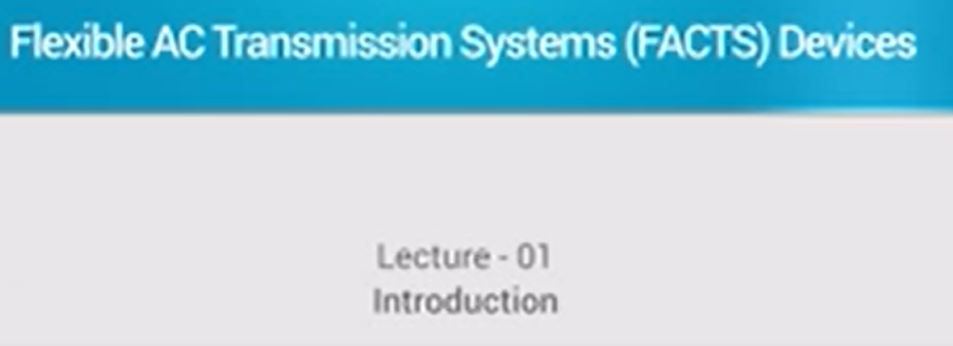

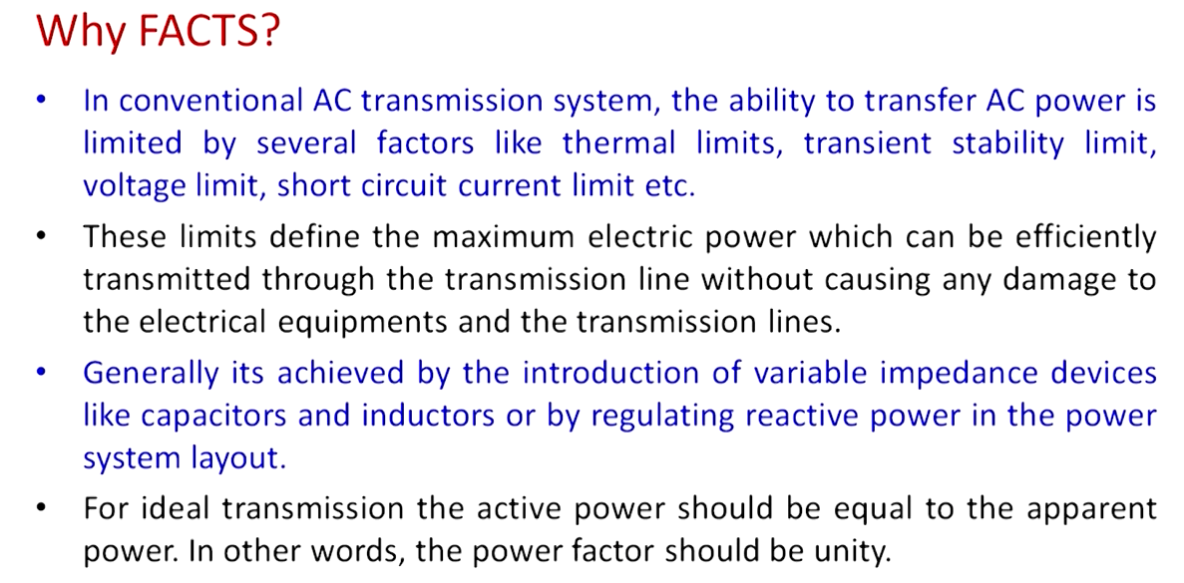

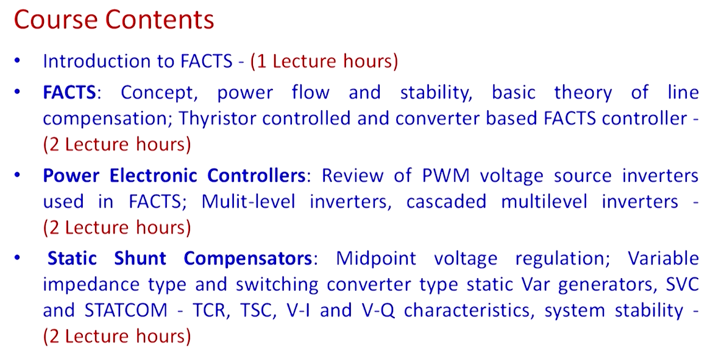

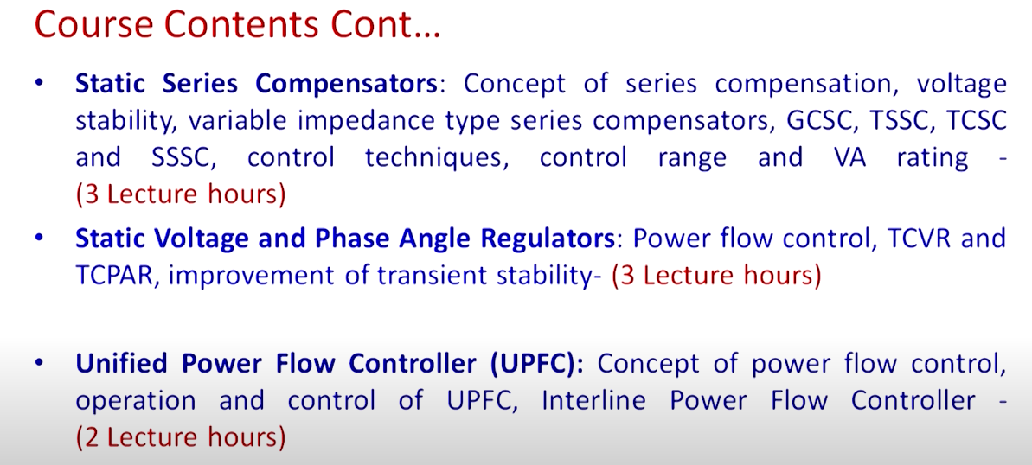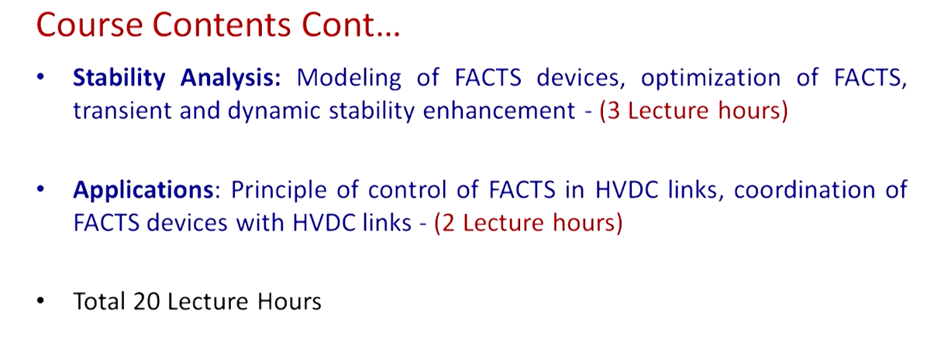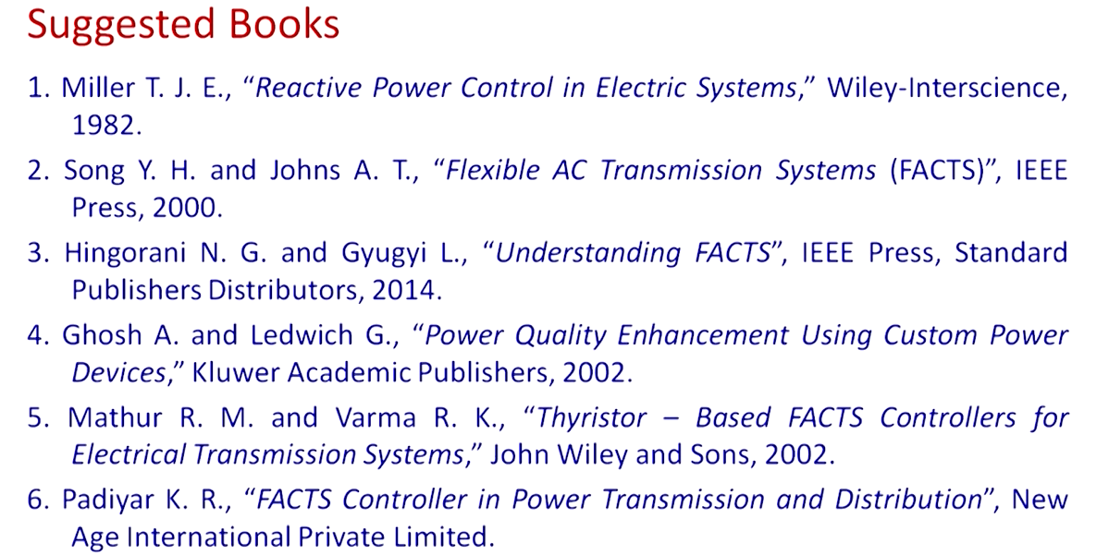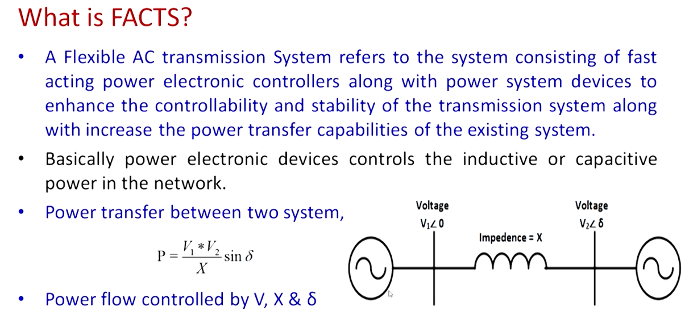

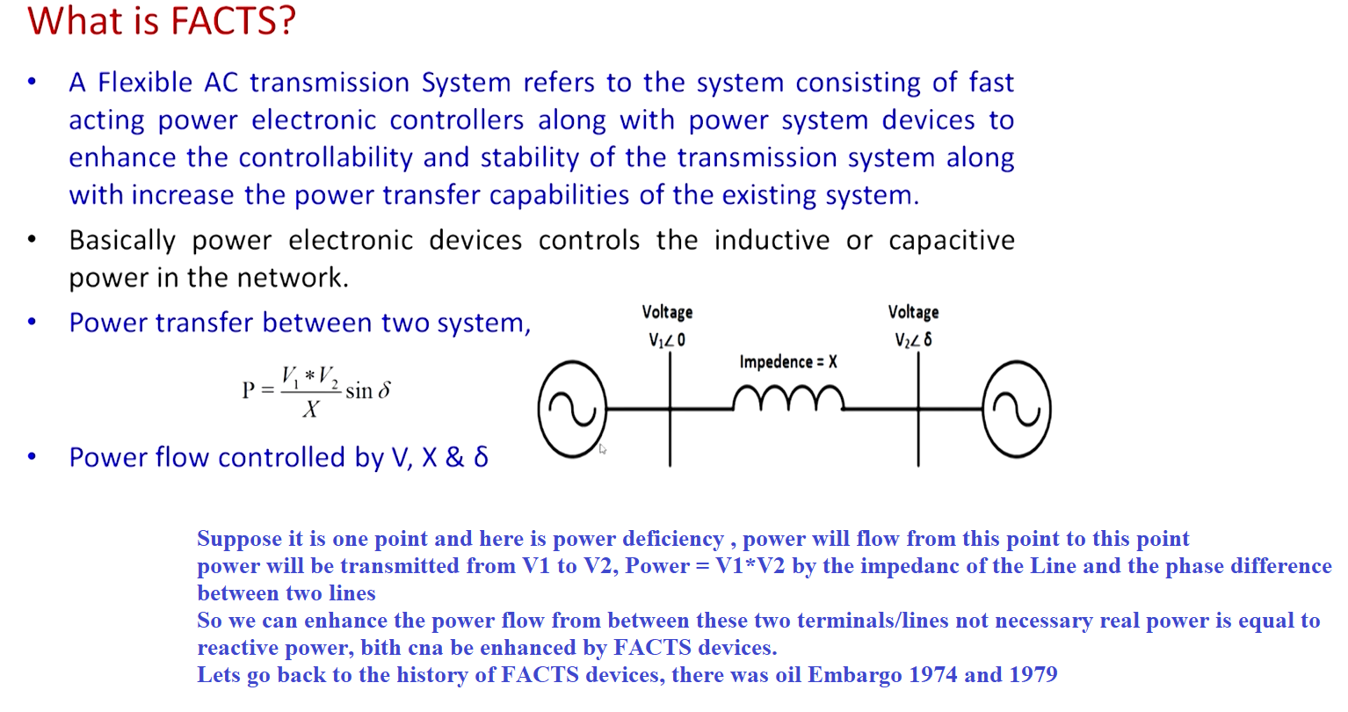

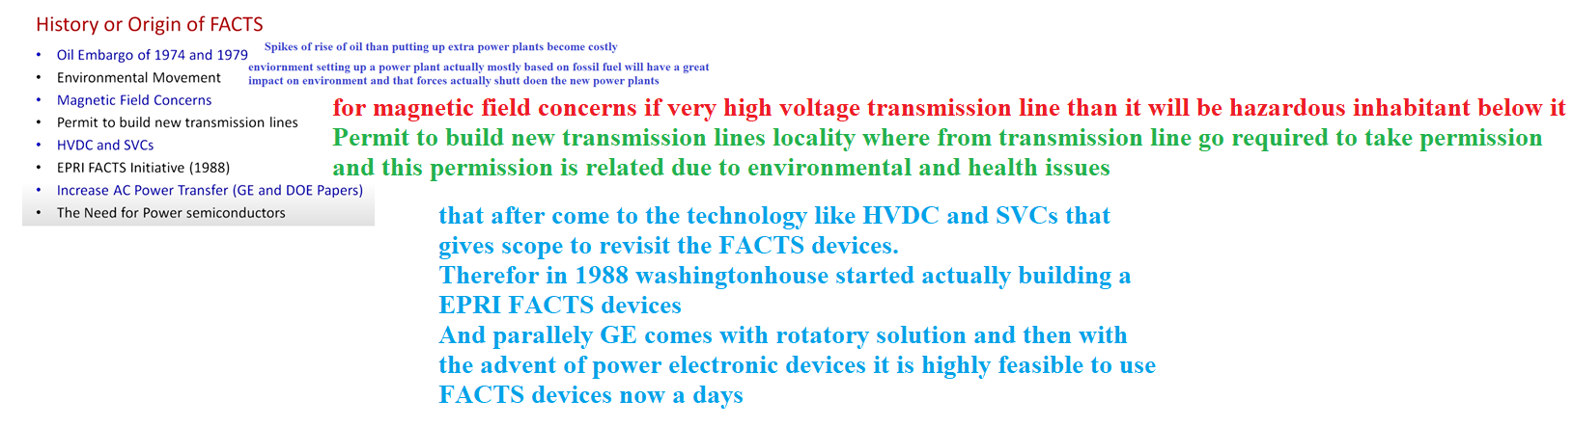

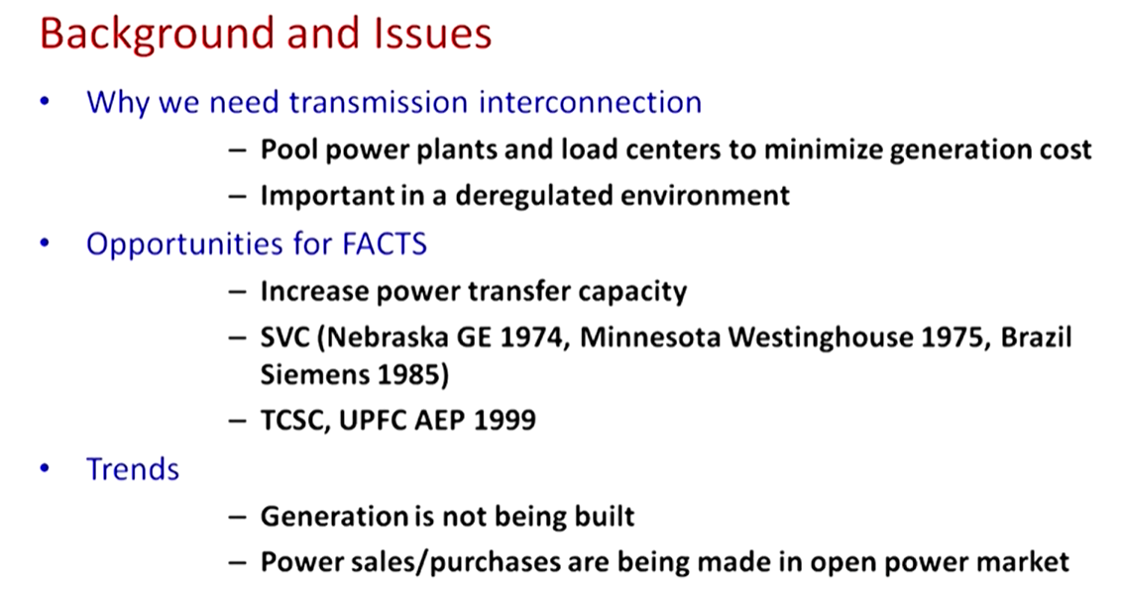



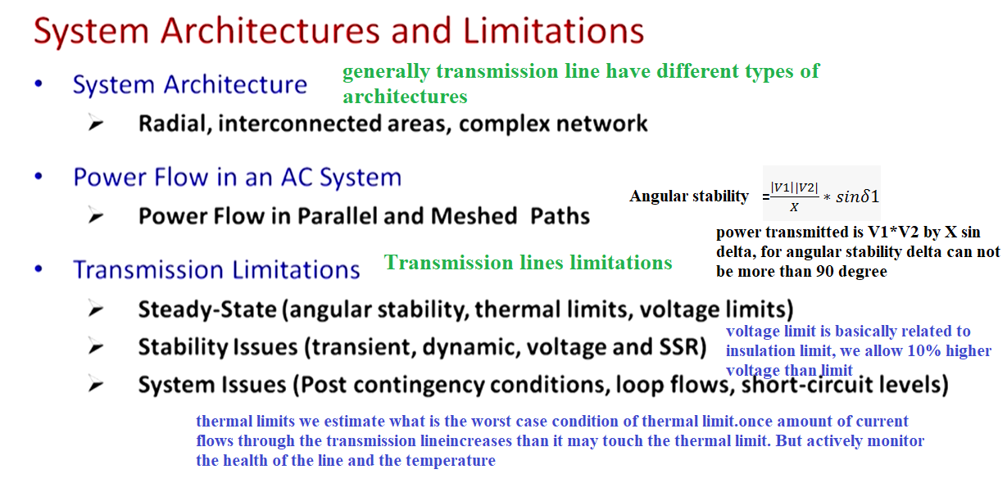

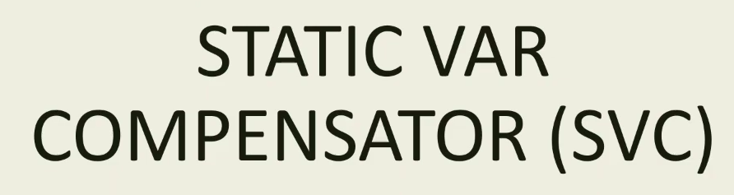

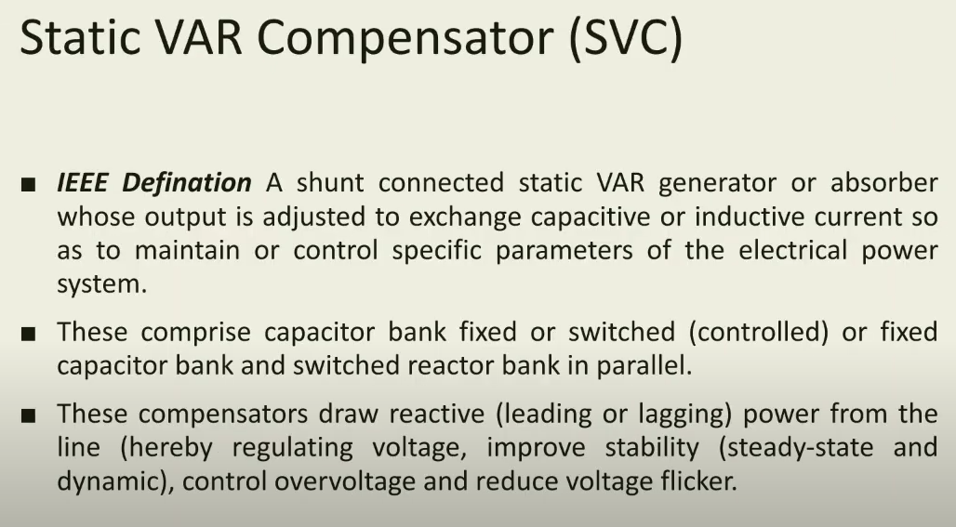

***Impedance and Power Triangle***

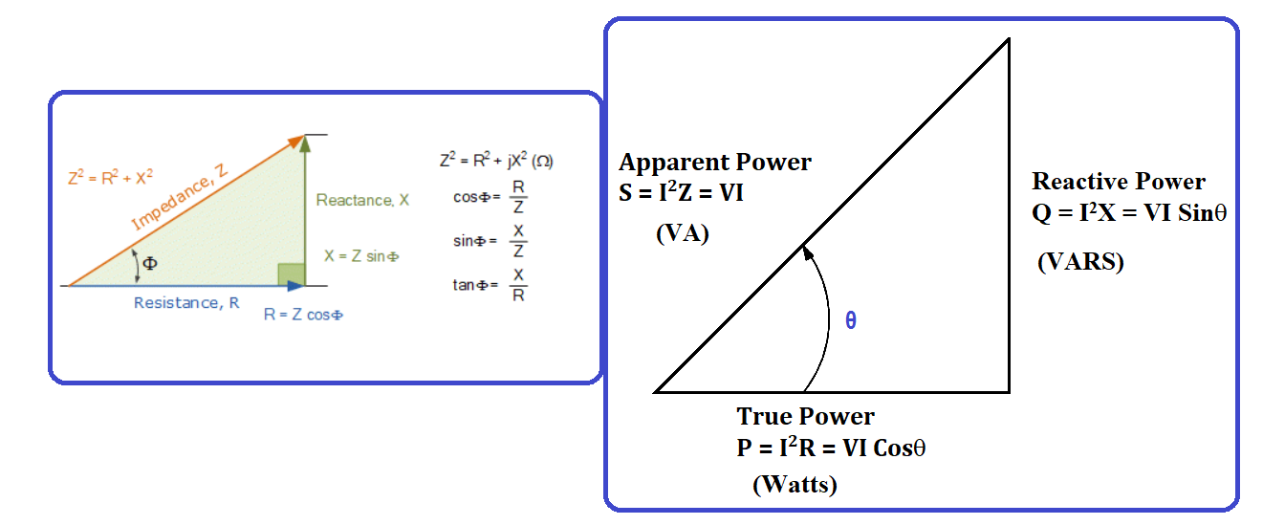

$$True Power=P= I^{2}R= I^{2}Z Cos∅=VICos∅$$

$$Reactive Power=Q= I^{2}X= I^{2}Z Sin∅=VISin∅$$

***What is FACTS?***

It is a Flexible Alternating current transmission system depend on power electronic-based system and other static controllers to enhance the controllability and increase the power transfer capability.

Initially FACTS introduced by Institute of Electrical and Electronics Engineers (IEEE) as a static equipment with electronic based system that provide the control of AC transmission system [1] . Siemens, defined FACTS as to Increase the reliability of AC grids and reduce the power delivery costs. They improve transmission quality and efficiency of power transmission by supplying inductive or reactive power to grid.

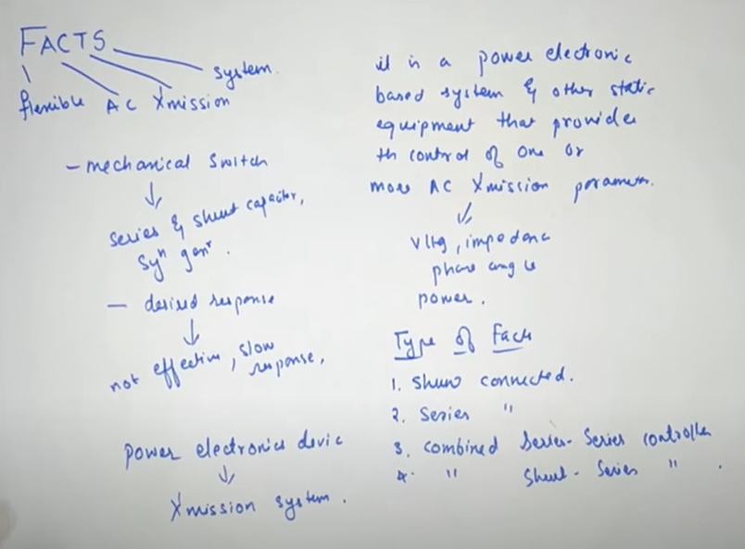

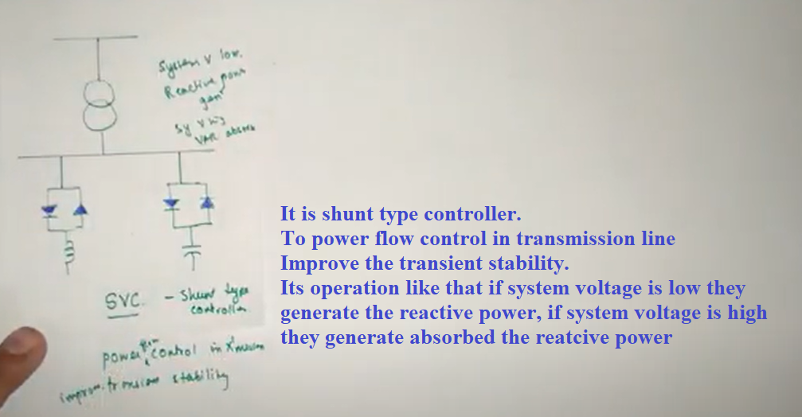

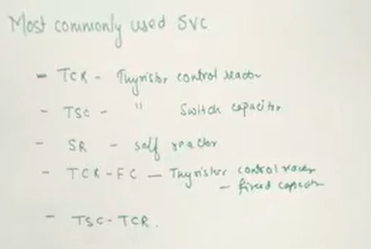

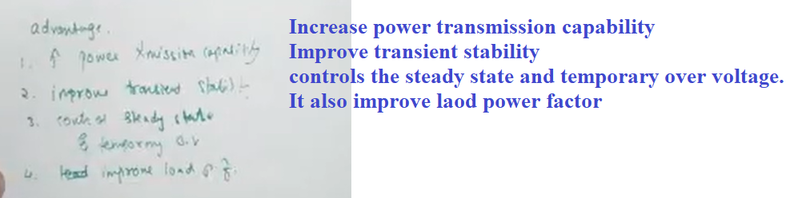

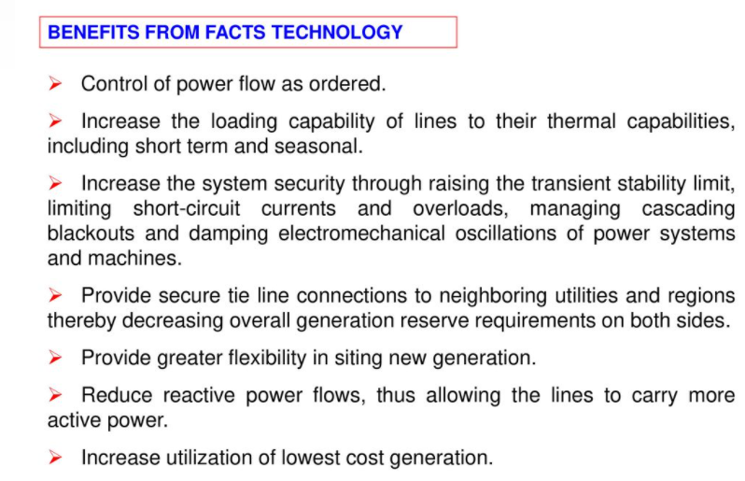

***FACTS Controller***

A power electronic-based system and other static equipment that provide control of one or more AC transmission system parameters.

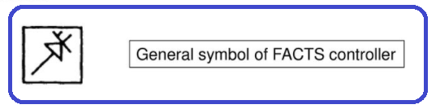

***Basic Types of FATCS Controllers***

Based on the connection, generally FACTS controller can be classified as follows:

* Series controllers
* Shunt controllers
* Combined series-series controllers
* Combined series-shunt controllers.

***Series Controllers***

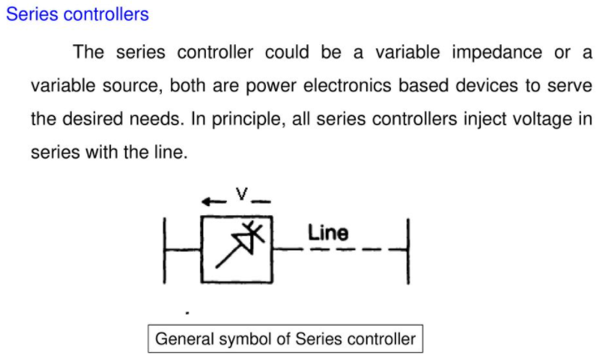

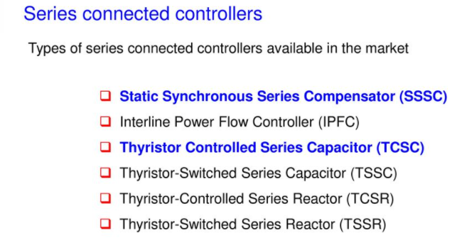

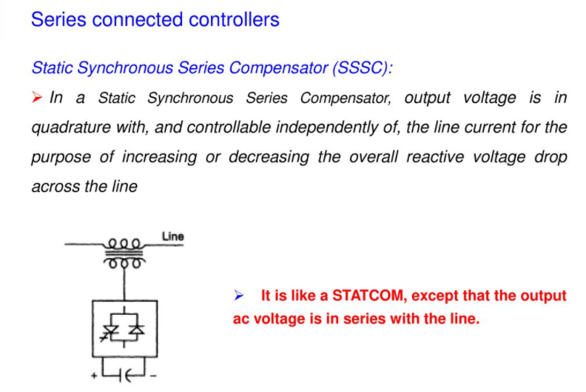

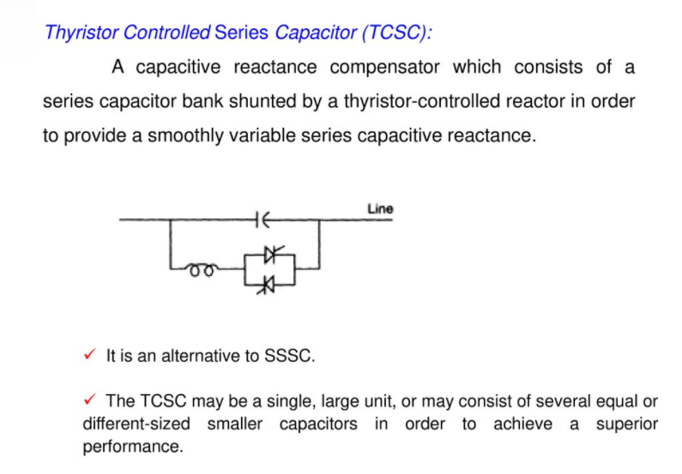

***Shunt Controllers***

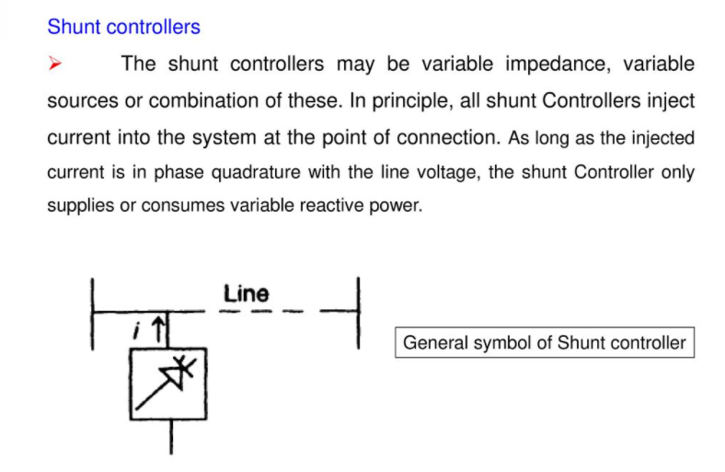

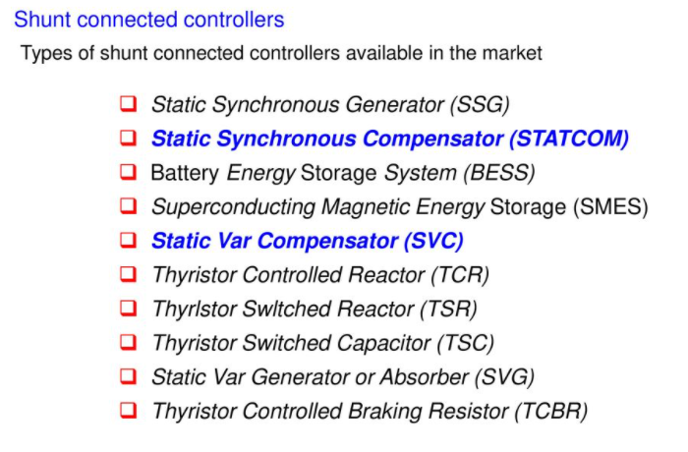

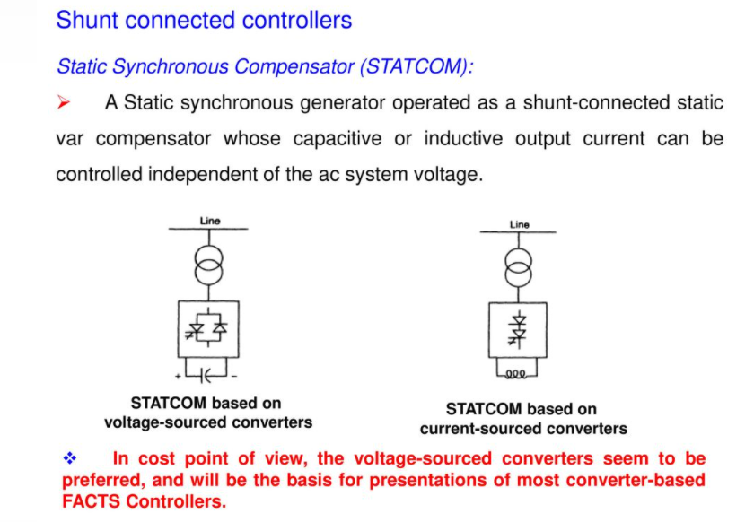

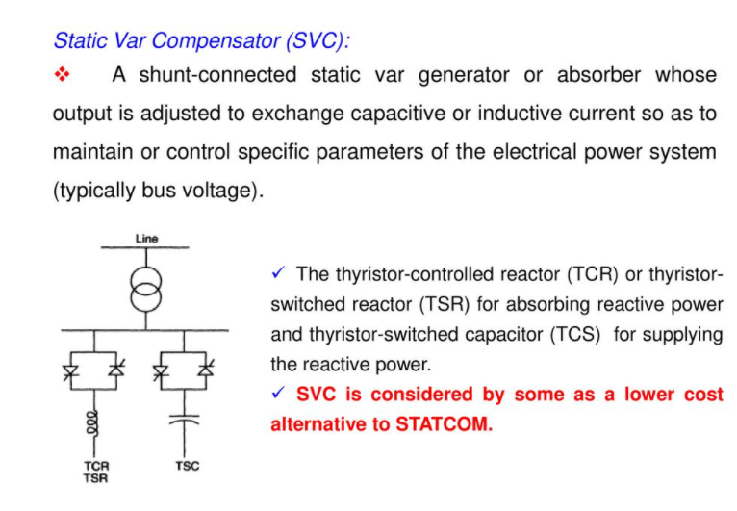

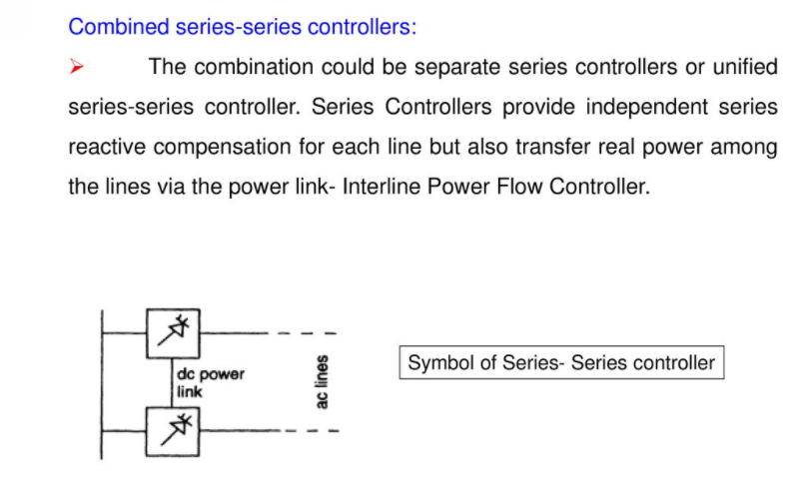

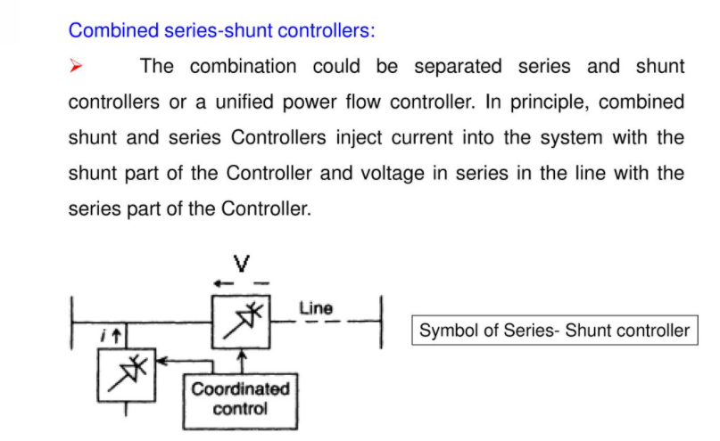

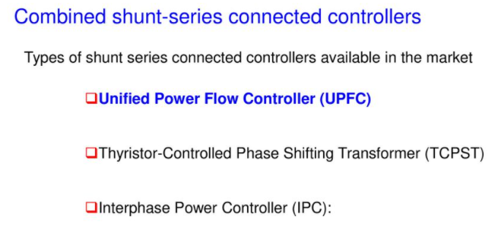

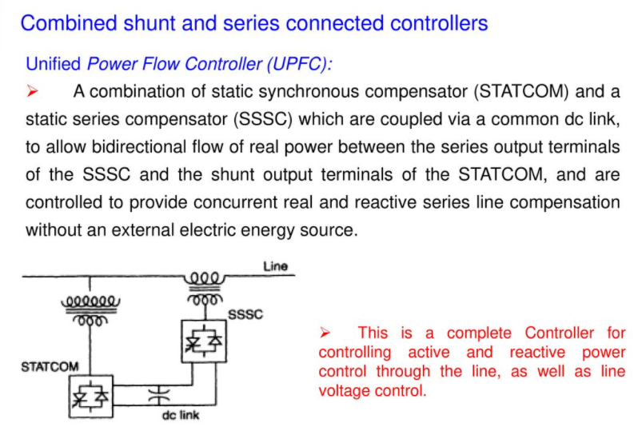

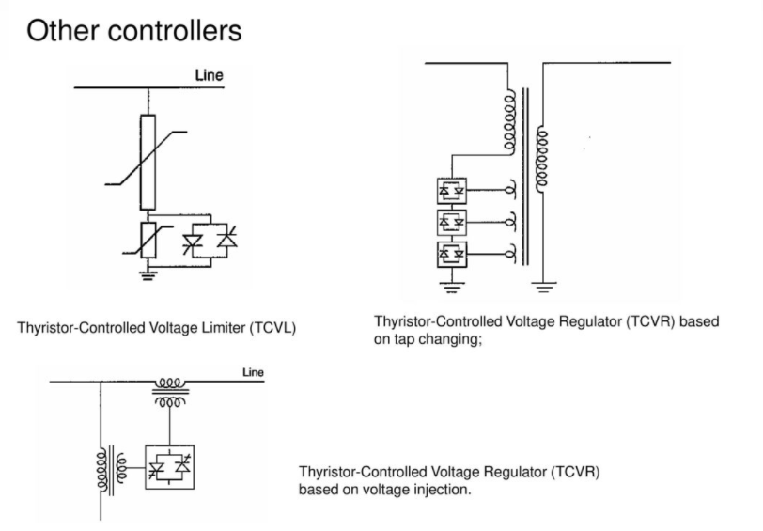

***LOAD COMPENSATION***

Load Compensation is used to improve the quality of the power supply at a load or group of loads. The main objectives of load compensation are power factor correction, improvement of voltage regulation and load balancing.

***COMPENSATING EQUIPMENT***

Compensating equipment such as power factor correction equipment is usually installed near to consumer premises.

***COMPENSATION IN POWER SYSTEM***

We know that electrical power is being generated in a faraway location and is being transmitted and distributed to the load centers. This electrical power must be of quality power. The quality power have the following important features like constant voltage, constant frequency, it should be harmonic free supply, constant power factor, minimum load interruption and it must be stable state if any circuit breaker interruption such features are called as Quality Power Supply.

***SHUNT COMPENSATION***

In shunt compensation, power system is connected in shunt (parallel) with the FACTS. It works as a controllable current source.

***TYPES OF SHUNT COMPENSATION***

There are two types of Shunt compensation, one is Shunt Capacitive Compensation and other is Shunt Inductive Compensation.

***Shunt Capacitive Compensation***

Shunt Capacitive Compensation approach is used to improve the power factor, because when inductive type load is connected to the transmission line power factor lags due to lagging of load current. To resolve this problem, use the shunt capacitor as a compensator which draws current leading the source voltage. Resultantly the power factor is improved.

***Shunt inductive compensation***

This method is used either when charging the transmission line, or, when there is very low load at the receiving end. Due to very low, or no load – very low current flows through the transmission line. Shunt capacitance in the transmission line causes voltage amplification (Ferranti effect). The receiving end voltage may become double the sending end voltage (generally in case of very long transmission lines). To compensate, shunt inductors are connected across the transmission line. The power transfer capability is thereby increased depending upon the power equation.

***Power Transfer Equations***

The power flowing across an arbitrary power transmission line depends on the Sending End Voltage (V1), Receiving End Voltage (V2), Line Impedance (Z = R + jX) and the phase difference between the Sending and Receiving terminals. Since the line resistance (R) is usually very small as compared to its reactance (X), so R is negligible in the Power Transfer Equation. Mathematically form of Power Transfer Equation are:

**P12 =**

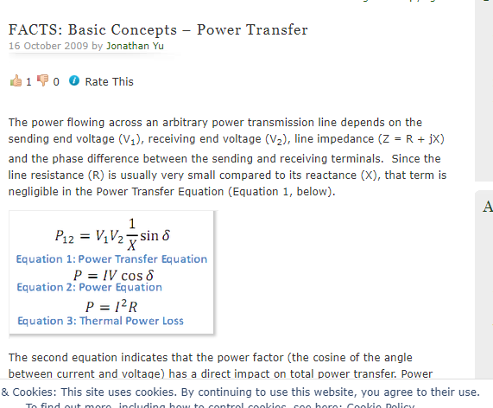

**References**

1. Edris, A.J.I.T.o.P.D., *Proposed terms and definitions for flexible AC transmission system (FACTS).* 1997. **12**(4).